**HR Analytics Project - SQL Insights**

**Objective:** Analyze employee data to find attrition, salary, and performance insights.

**Dataset:** 1,470 employees

1. **Attrition by Department**

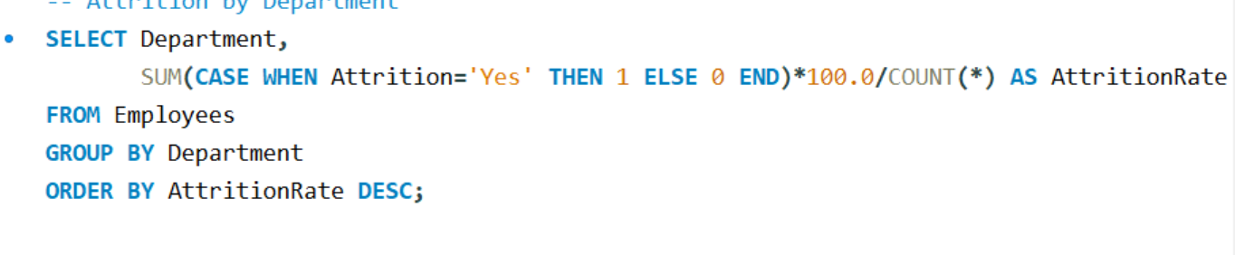

**Result:**

* Sales department shows the highest atrrition rate (20.6%), followed closely by Human Resources (19%).
* Research & Development has the lowest attrition at 13.8%.
* This indicates that employees in Sales and HR are at higher risk of leaving, suggesting the need for better retention strategies, training, and engagement programs in these departments.

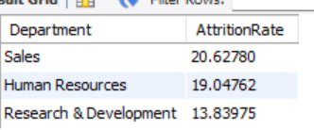

1. **Average Salary by JobRole**

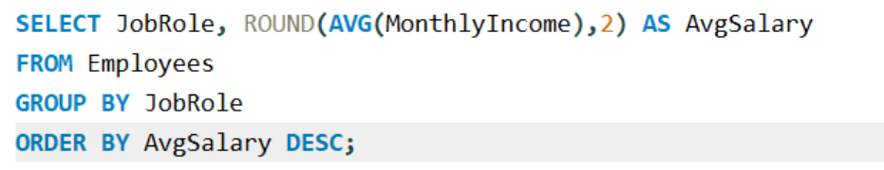

**Result:**

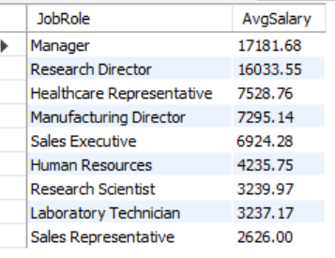

* Managers (17,181) and Research Directors (16,033) earn the highest salaries, nearly 6 times higher than many other roles.
* Healthcare Representatives (7,528), Research Scientists (6,924), and Lab Technicians (3,237) earn the lowest average salaries.
* Sales Representatives (2,626), Research Scientists (3,239), and Lab Technicians (3,237) earn the lowest average salaries.
* The significant salary gap across job roles may cause dissatisfaction among employees in lower-paying posistions, potentially contributing to higher attrition rates in those groups

1. **Gender-wise Salary**

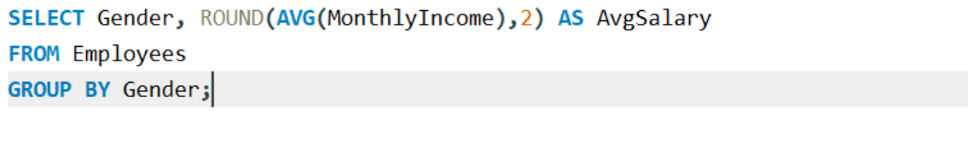

**Result:**

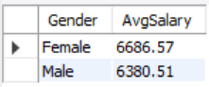

* On average, female employees earn slightly higher salaries (₹6686) compared to male employees (₹6380).
* This is interesting because in many organizations, males are usually paid more.
* The result suggests that salary distribution is relatively balanced across genders in this dataset, though further analysis is needed to confirm equity across all job roles and departments.

1. **Attrition by Age Group**

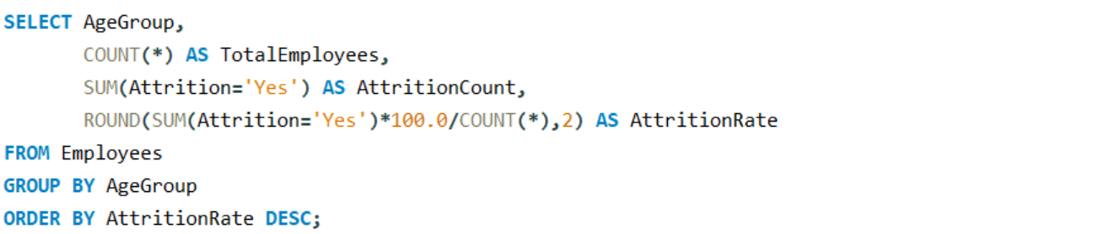

**Result:**

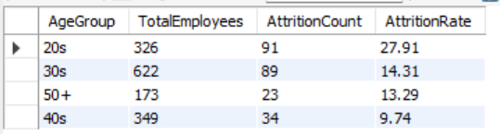

* Employees in their 20s have the highest attrition rate (27.9%), nearly 3 times higher than employees in their 40s.
* Attrition decreases with age, with employees in their 40s showing the lowest attrition (9.7%).
* This trend suggests that younger employees are more likely to leave early in their careers, possibly due to better opportunities, lack of growth, or dissatisfaction with current roles.
* Companies should focus on career development, mentoring, and retention programs targeted at younger employees to reduce turnover.

1. **Attrition By Tenure**

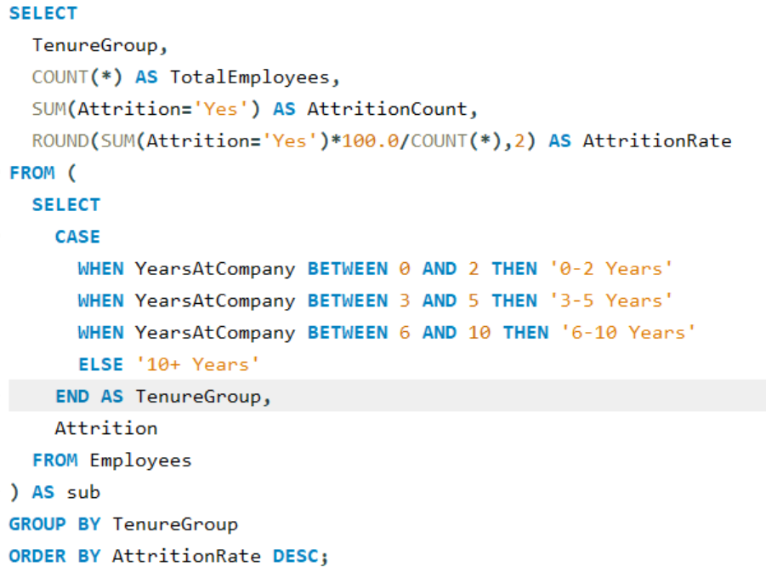

**Result:**

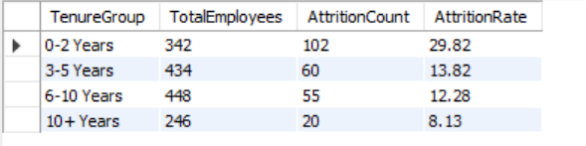

* Employees with 0–2 years of experience have the highest attrition rate (29.8%), meaning nearly 1 in 3 new hires leave within the first 2 years.
* Attrition steadily decreases with tenure, with employees staying longer (10+ years) showing the lowest attrition (8.1%).
* This pattern indicates that the company faces major challenges in early-career retention, suggesting the need for stronger onboarding, mentorship, and career growth opportunities in the initial years.